Table of Contents

1. Overview 2
2. System Layout 3
3. Handling 6
4. Wiring Connection 7
5. Touch Display Screens 8
5.1 One System Screens 8
5.2 Two Systems Screens 10
5.3 Three Systems Screens 13
5.4 Four Systems Screens 17
6. NatureSeal® Meter Screens 21
7. Sensor Maintenance 22
8. Calibration 23
8.1 Sensitivity Calibration 23
8.2 Zero Calibration 23
8.3 Sensor to Touch Screen Calibration 23
9. NatureSeal® Concentration Meter Error Messages 24

1. Overview
The SA500 Automatic Control System is a specialized system for maintaining the level of NatureSeal® concentrate in a Treatment Tank during normal production processing.

The system has three major processes – the chemical injection process, the sampling process, and the measurement process. Using the specially designed Ascorbate sensor, it sends a signal to the control panel; and depending on the setpoint the control panel will automatically add the correct amount of Ascorbate into the process tank.

The system continuously monitors the NatureSeal® concentration and displays the concentration value in %.

The system automatically dispenses the correct amount of NatureSeal® concentrate to maintain the amount of chemical in a process tank. In order to optimize the measurement and treatment, the SA500 samples a small amount of the process solution. A highly specialized sensor measures the concentration of the NatureSeal®. The peristaltic pump controlled by the control panel automatically dispenses the treatment to the tank and maintains it to the set point level. A green indicator light on the touch screen will turn ON when the pump is ON.

A built-in safety alarm alerts the user if the NatureSeal® level falls too low or rises too high. The system maintains the concentration of the NatureSeal® at the specified range so that if the NatureSeal® level gets out of this range, the system will turn on a red indicator light.

A built-in datalogger maintains a record of the readings with date and time reference.

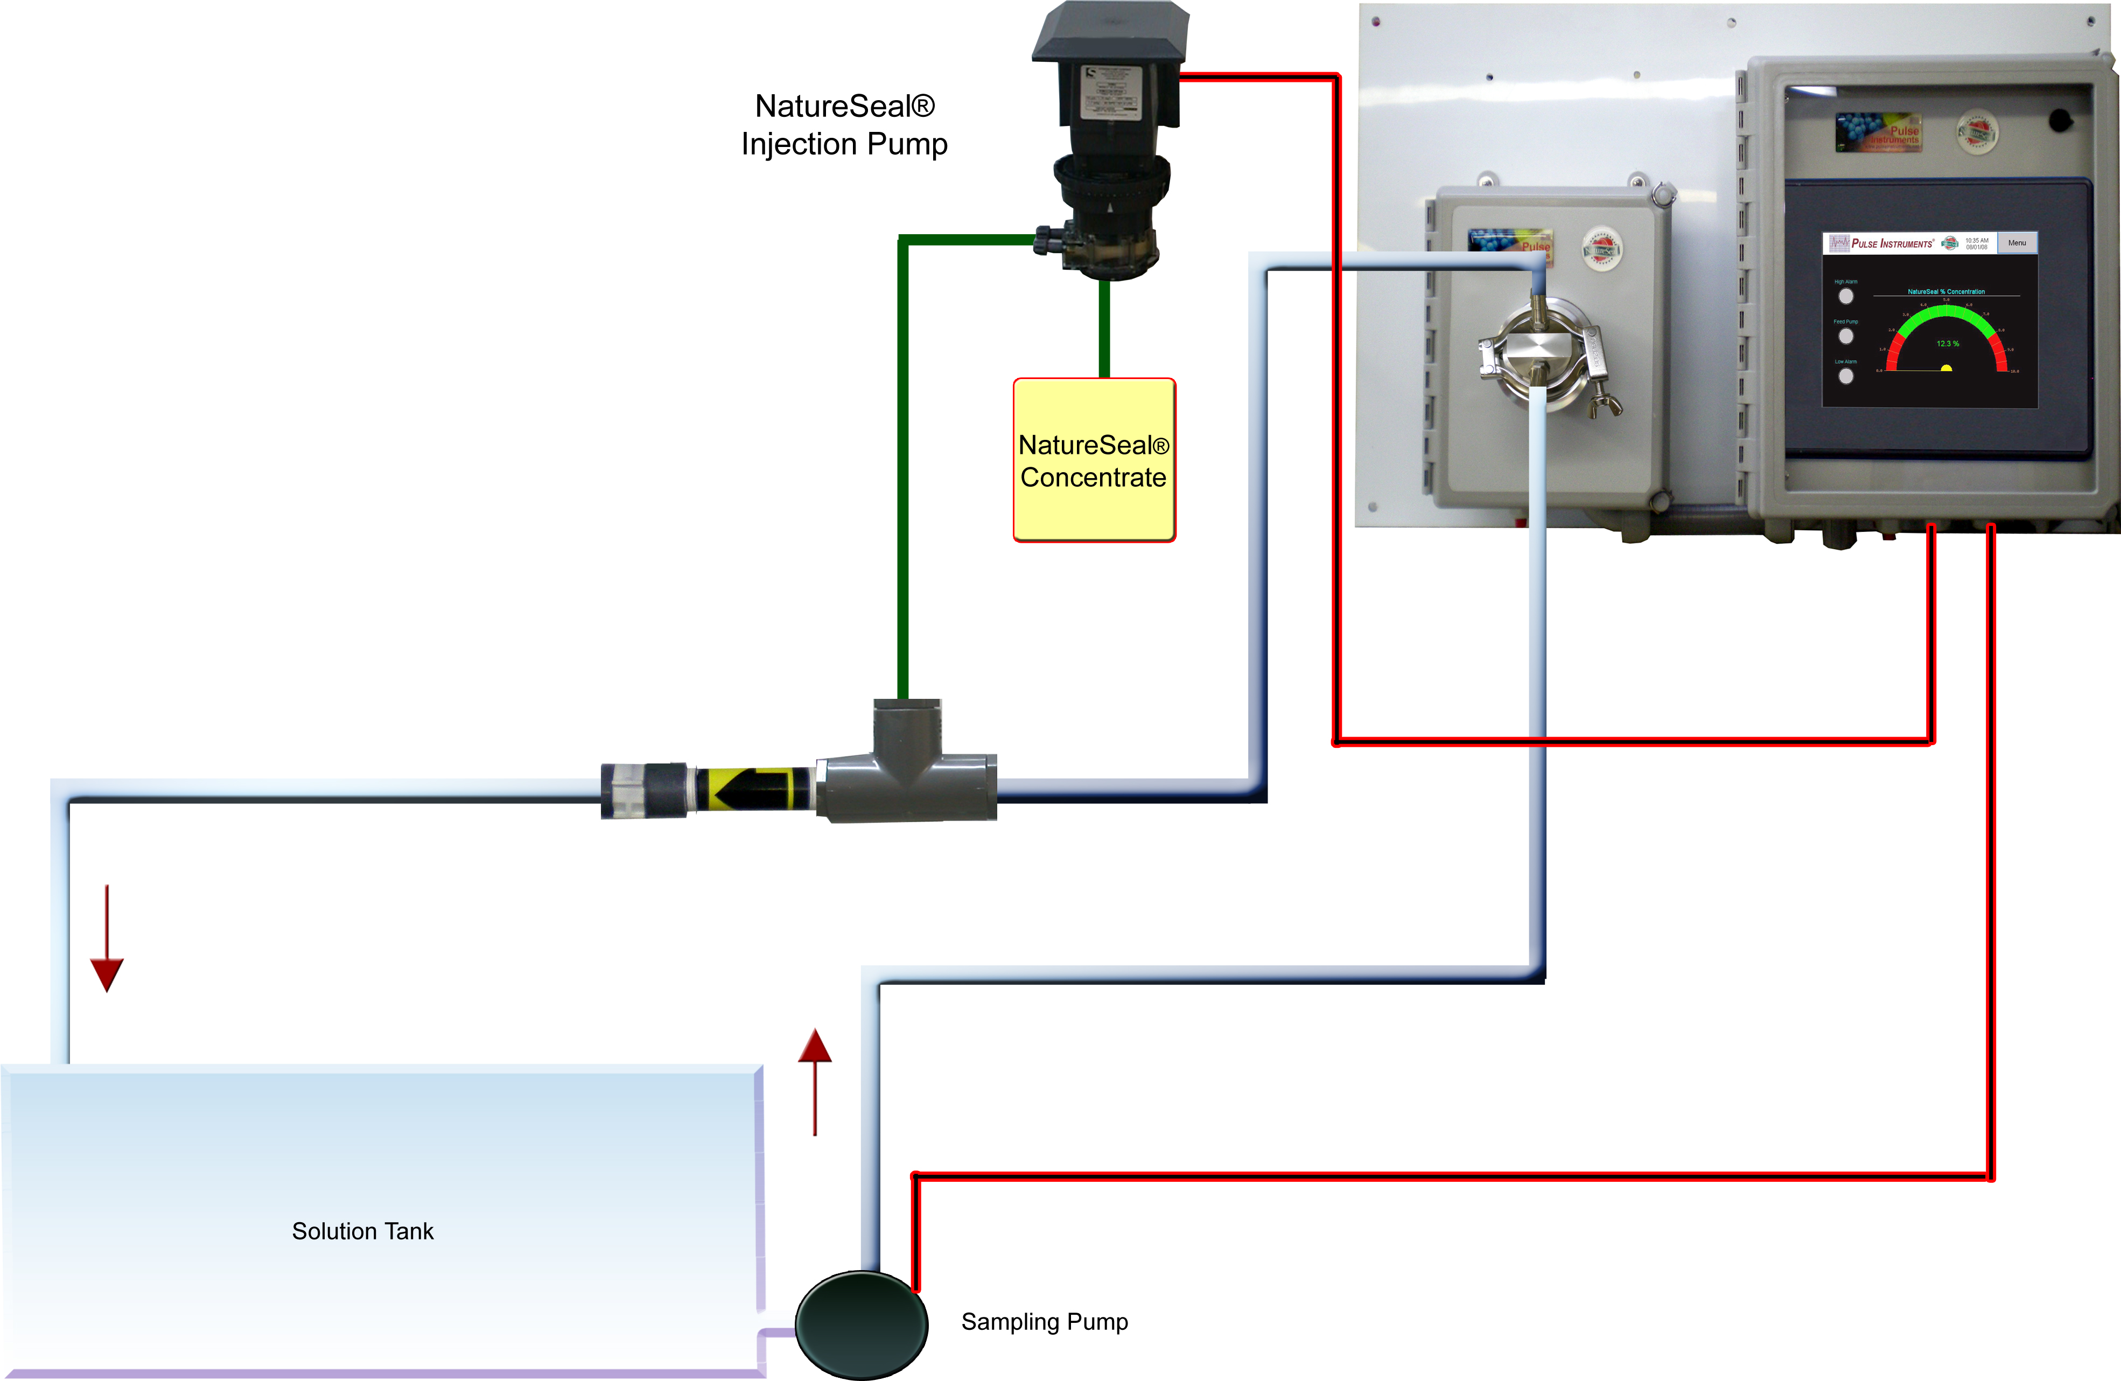

2. System Layout

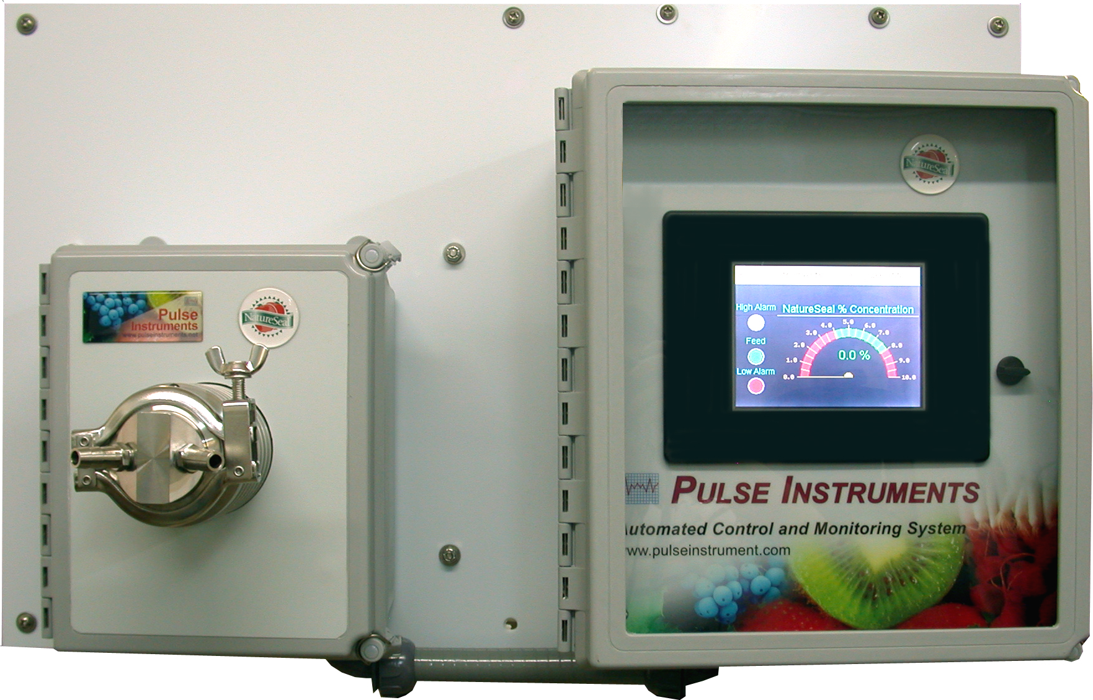

NatureSeal® Sensor
Touch Screen for Monitor and Control

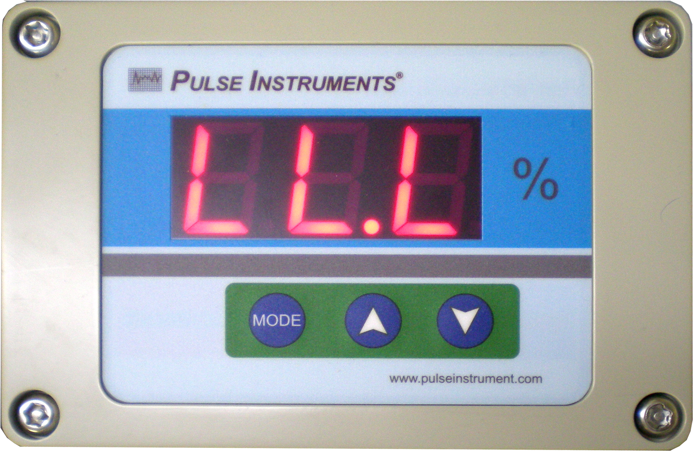
NatureSeal® Concentration Display

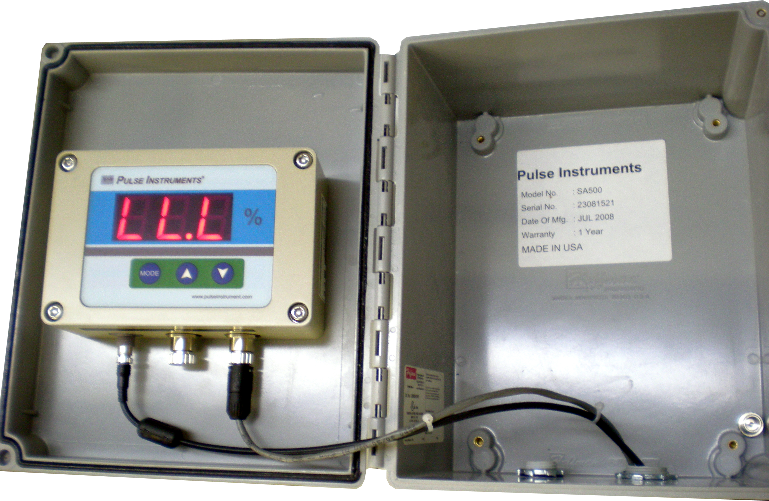

Arrow Buttons

Mode Button

NatureSeal® Concentration Meter

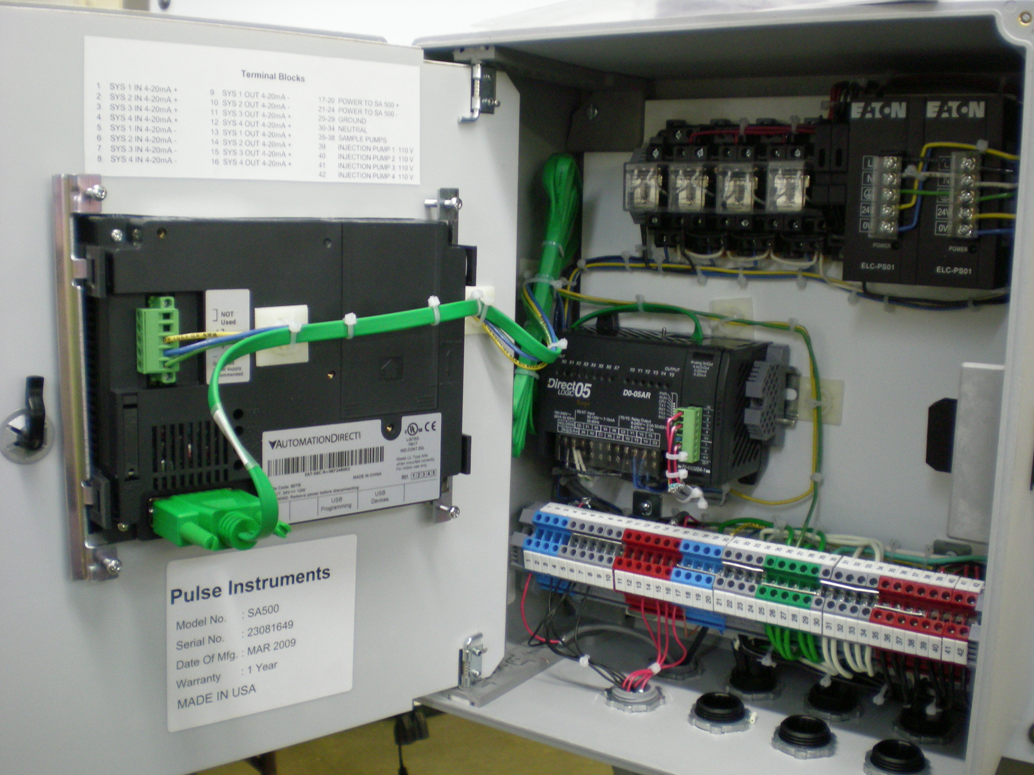
PLC
Terminal Blocks
Relays
Touch Screen

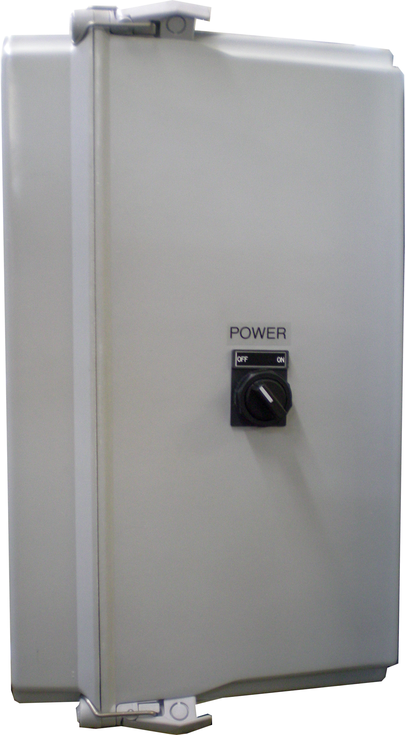

Main Power Switch On the Side of the Touch Screen Panel

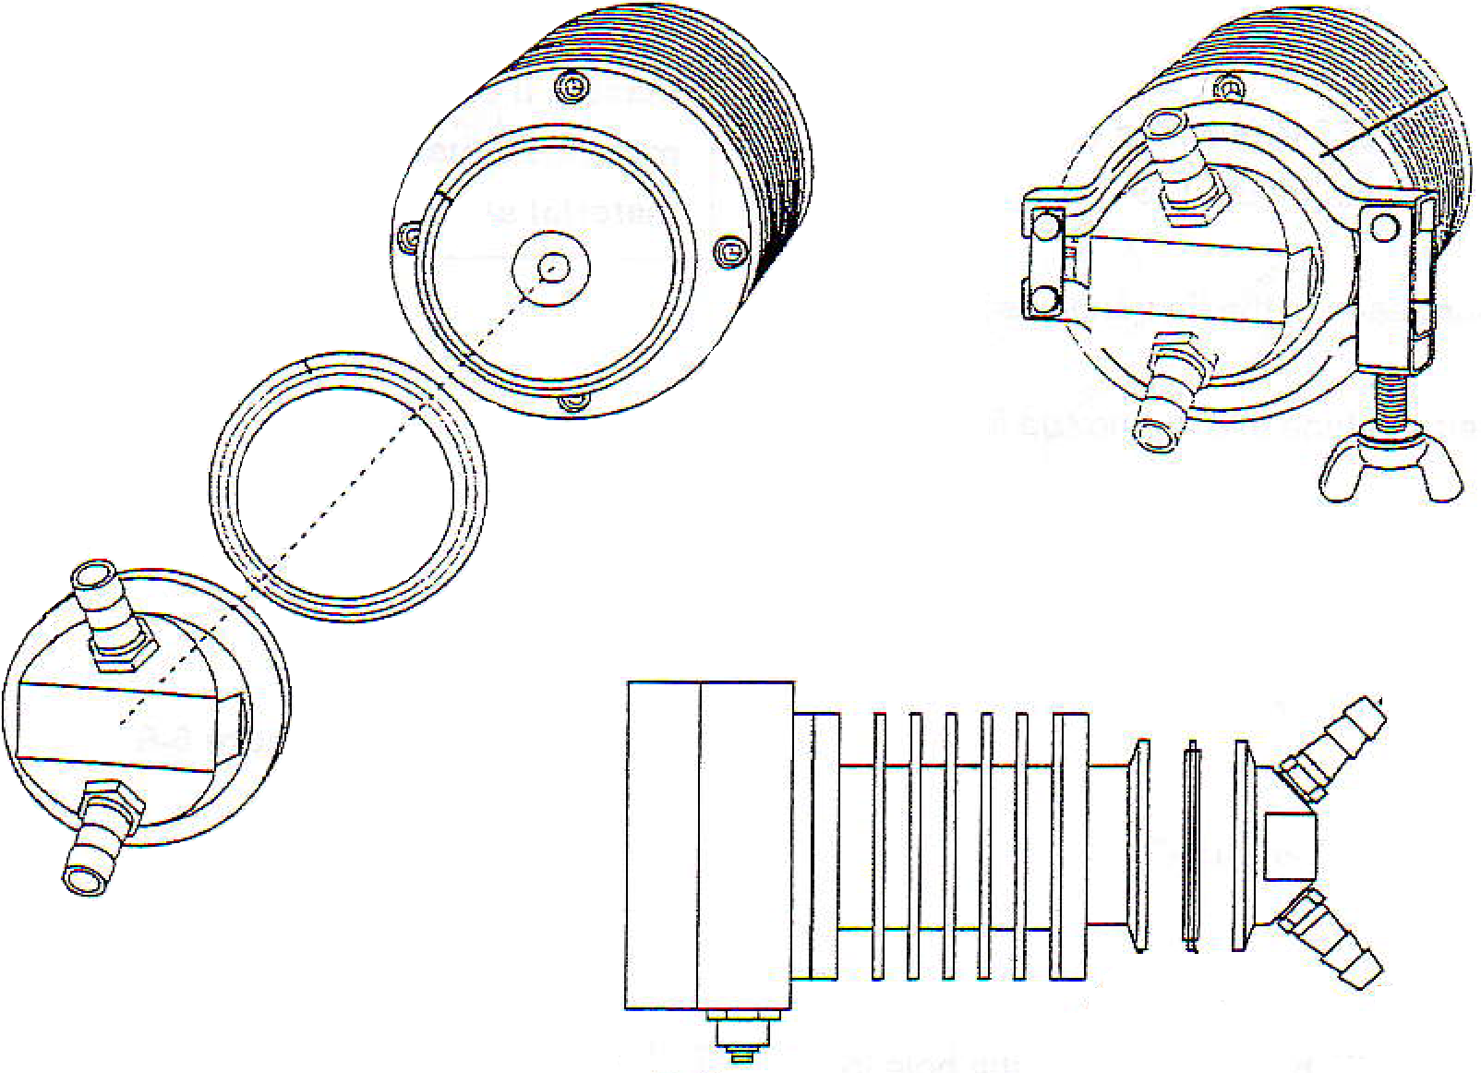
Sample Outlet
Sensor Area
O-ring
Sampling Inlet
and Outlet
Clamp
Sample Inlet
O-ring
Sensor Area

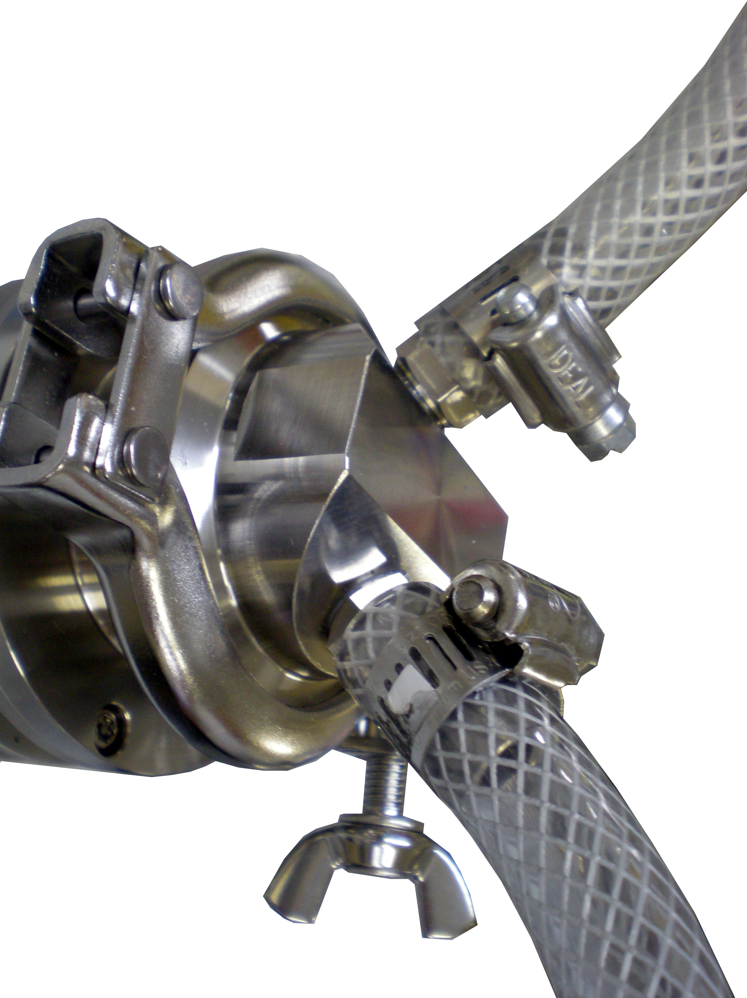
Sampling Loop Assembly
5/8” OD x 3/8” ID Hose

3. Handling
CAUTION
- Do not pour in a sample that can damage the sensor or sample inlet unit. When the power is turned on. Do not pour in a sample that is at below 5°C or above 100°C.

- When pouring high temperature cleaning water in, be sure to turn off the power (DC24V) in advance. Turn off the power to the unit. Cleaning water should be kept at no higher than 130°C and should be poured for less than 30 minutes at one time.

- If there is a possibility that the sample could stain the sensor, immediately clean the clean according to the procedure described.

- If the unit is not to be used over a long period of time, be sure to turn off the power.

- Do not insert or pull out the connector and plug with wet hands.

- Pulling the cable will damage the cable and may cause fire or electrical shock.

- Do not connect the cables while the power is connected.

- Do not drop the instrument or subject it to any strong shock.

4. Wiring Connection
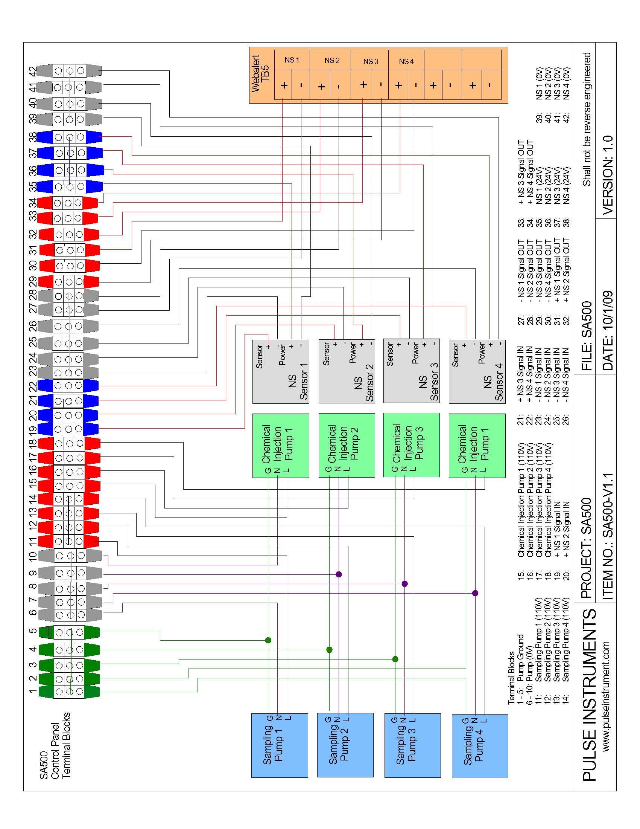

5. Touch Display Screens

5.1 One System Screens
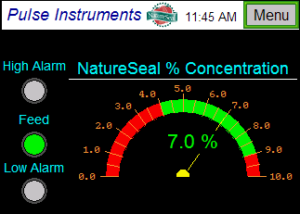 | Overview  Displays the NatureSeal® concentration in percentage (0 to 10%) for one system. High and Low alarm lights and chemical feed pump indicator light.  Press on the Menu button to go to other screens.
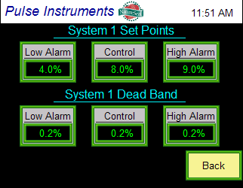 | Set Points and Dead Band  Press on the number area to enable a keypad to enter set point and dead bad values.  Press the Back button to go back to the Overview screen.  This screen is password protected. Default password is “0”.
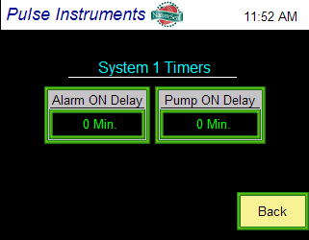 | Timers  Press on the number area to enable a keypad to enter timer values.  Press the Back button to go back to the Overview screen.  This screen is password protected. Default password is “0”.
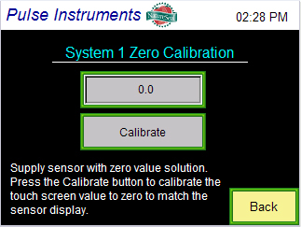 | System 1 Zero Calibration  Supply apple water to the sensor and make sure the value on the sensor display is zero. If it is not zero, calibrate the sensor (see Section 8.2).  Press on the Calibrate button one time to match the touch screen and sensor display value.
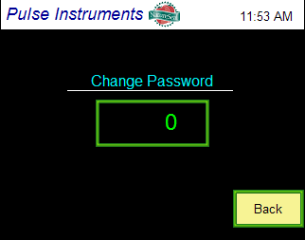 | Change Password  Press on the number area to enable a keypad to enter the new password.  Press the Back button to go back to the Overview screen.  This screen is password protected. Default password is “0”. Once a new password is entered, please remember to write down the password.
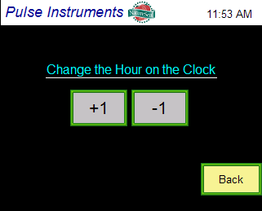 | Clock Setting  Press the “+1 Hour” to increase the hour and press the “-1 Hour” to decrease the hour on the clock.  Press the Back button to go back to the Overview screen.
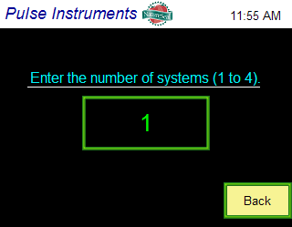 | Select Number of Systems  Press on the number area to enable a keypad to enter the number of systems the SA500 system will control. The SA500 system is capable of monitoring and controlling up to 4 systems.  Press the Back button to go back to the Overview screen.
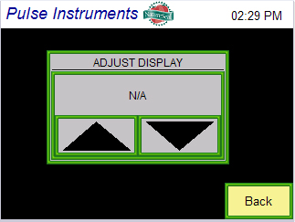 | Display Contrast  To brighten the display, press the up arrow button. To darken the display, press the down arrow button.

5.2 Two Systems Screens
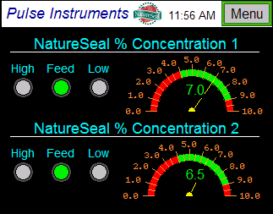 | Overview  Displays the NatureSeal® concentration in percentage (0 to 10%) for two systems. High and Low alarm lights and chemical feed pump indicator lights for corresponding system.  Press on the Menu button to go to other screens.
Set Points and Dead Band for System 1

Press on the number area to enable a keypad to enter set point and dead bad values.

Press the Back button to go back to the Overview screen.

This screen is password protected. Default password is “0”.
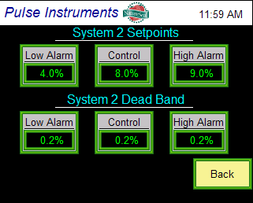 | Set Points and Dead Band for System 2  Press on the number area to enable a keypad to enter set point and dead bad values.  Press the Back button to go back to the Overview screen.  This screen is password protected. Default password is “0”.
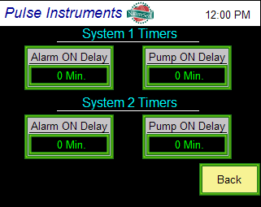 | Timers for System 1 and System 2  Press on the number area to enable a keypad to enter timer values.  Press the Back button to go back to the Overview screen.  This screen is password protected. Default password is “0”.
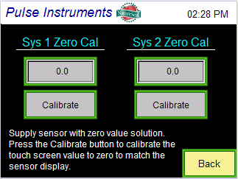 | System 1-2 Zero Calibration  Supply apple water to the sensor and make sure the value on the sensor display is zero. If it is not zero, calibrate the sensor (see Section 8.2).  Press on the Calibrate button one time to match the touch screen and sensor display value.
Change Password

Press on the number area to enable a keypad to enter the new password.

Press the Back button to go back to the Overview screen.

This screen is password protected. Default password is “0”. Once a new password is entered, please remember to write down the password.
Clock Setting

Press the “+1 Hour” to increase the hour and press the “-1 Hour” to decrease the hour on the clock.

Press the Back button to go back to the Overview screen.
Select Number of Systems

Press on the number area to enable a keypad to enter the number of systems the SA500 system will control. The SA500 system is capable of monitoring and controlling up to 4 systems.

Press the Back button to go back to the Overview screen.
Display Contrast

To brighten the display, press the up arrow button. To darken the display, press the down arrow button.

5.3 Three Systems Screens
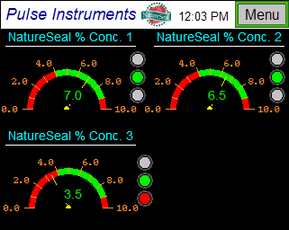 | Overview  Displays the NatureSeal® concentration in percentage (0 to 10%) for three systems. High and Low alarm lights and chemical feed pump indicator lights for corresponding system.  Press on the Menu button to go to other screens.
Set Points and Dead Band for System 1

Press on the number area to enable a keypad to enter set point and dead bad values.

Press the Back button to go back to the Overview screen.

This screen is password protected. Default password is “0”.
Set Points and Dead Band for System 2

Press on the number area to enable a keypad to enter set point and dead bad values.

Press the Back button to go back to the Overview screen.

This screen is password protected. Default password is “0”.
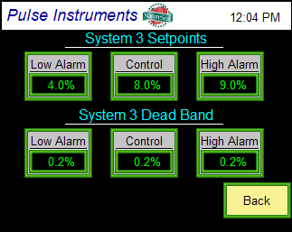 | Set Points and Dead Band for System 3  Press on the number area to enable a keypad to enter set point and dead bad values.  Press the Back button to go back to the Overview screen.  This screen is password protected. Default password is “0”.
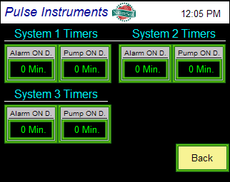 | Timers for System 1, 2, and 3  Press on the number area to enable a keypad to enter timer values.  Press the Back button to go back to the Overview screen.  This screen is password protected. Default password is “0”.
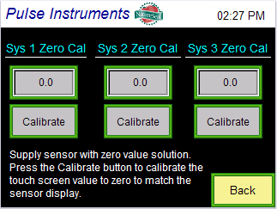 | System 1-3 Zero Calibration  Supply apple water to the sensor and make sure the value on the sensor display is zero. If it is not zero, calibrate the sensor (see Section 8.2).  Press on the Calibrate button one time to match the touch screen and sensor display value.
Change Password

Press on the number area to enable a keypad to enter the new password.

Press the Back button to go back to the Overview screen.

This screen is password protected. Default password is “0”. Once a new password is entered, please remember to write down the password.
Clock Setting

Press the “+1 Hour” to increase the hour and press the “-1 Hour” to decrease the hour on the clock.

Press the Back button to go back to the Overview screen.
Select Number of Systems

Press on the number area to enable a keypad to enter the number of systems the SA500 system will control. The SA500 system is capable of monitoring and controlling up to 4 systems.

Press the Back button to go back to the Overview screen.
Display Contrast

To brighten the display, press the up arrow button. To darken the display, press the down arrow button.

5.4 Four Systems Screens
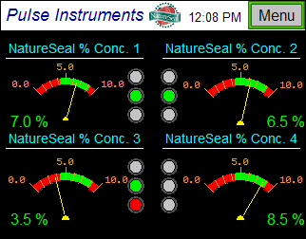 | Overview  Displays the NatureSeal® concentration in percentage (0 to 10%) for four systems. High and Low alarm lights and chemical feed pump indicator lights for corresponding system.  Press on the Menu button to go to other screens.
Set Points and Dead Band for System 1

Press on the number area to enable a keypad to enter set point and dead bad values.

Press the Back button to go back to the Overview screen.

This screen is password protected. Default password is “0”.
Set Points and Dead Band for System 2

Press on the number area to enable a keypad to enter set point and dead bad values.

Press the Back button to go back to the Overview screen.

This screen is password protected. Default password is “0”.
Set Points and Dead Band for System 3

Press on the number area to enable a keypad to enter set point and dead bad values.

Press the Back button to go back to the Overview screen.

This screen is password protected. Default password is “0”.
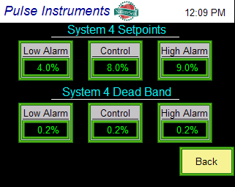 | Set Points and Dead Band for System 4  Press on the number area to enable a keypad to enter set point and dead bad values.  Press the Back button to go back to the Overview screen.  This screen is password protected. Default password is “0”.
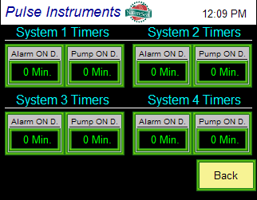 | Timers for System 1, 2, 3, and 4  Press on the number area to enable a keypad to enter timer values.  Press the Back button to go back to the Overview screen.  This screen is password protected. Default password is “0”.
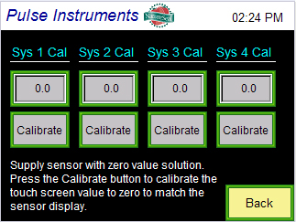 | System 1-4 Zero Calibration  Supply apple water to the sensor and make sure the value on the sensor display is zero. If it is not zero, calibrate the sensor (see Section 8.2).  Press on the Calibrate button one time to match the touch screen and sensor display value.
Change Password

Press on the number area to enable a keypad to enter the new password.

Press the Back button to go back to the Overview screen.

This screen is password protected. Default password is “0”. Once a new password is entered, please remember to write down the password.
Clock Setting

Press the “+1 Hour” to increase the hour and press the “-1 Hour” to decrease the hour on the clock.

Press the Back button to go back to the Overview screen.
Select Number of Systems

Press on the number area to enable a keypad to enter the number of systems the SA500 system will control. The SA500 system is capable of monitoring and controlling up to 4 systems.

Press the Back button to go back to the Overview screen.
Display Contrast

To brighten the display, press the up arrow button. To darken the display, press the down arrow button.

6. NatureSeal® Meter Screens
See Section 1 for the image of the NatureSeal® concentration meter.

Parameters | Description
[1] | Calibration
[2] | Temperature correction factor
[3] | Recorder output, lower limit value
[4] | Recorder output, upper limit value

7. Sensor Maintenance
- If the sensor becomes dirty, wipe it with a soft cloth.
- Do not use benzine, paint thinner, etc. to clean the instrument.

- Detach the clamp that connects the sensor body and the sample inlet.
- Remove the sample inlet unit from the sensor body.
- Clean the sensor surface carefully with soft material such as a tissue soaked with warm water.
- NEVER scrub with sharp material that could cause damage to the sensor.
- After cleaning, attach the sample inlet unit back onto the sensor body using the clamp.

8. Calibration

8.1 Sensitivity Calibration
Note: Before calibration, please make sure that the sensor surface is clean.

- Confirm that the sampling loop is properly connected to the meter.
- Let the sample flow into the piping.
- Open the NatureSeal® sensor panel (see Section 2).
- Press the MODE key for one second, then [1] is displayed.
- When the % value blinks, adjust the displayed value to the sample value based on titration by using the up [↑] and or the [↓] keys.
- Pressing the MODE key terminates adjustment and the display returns to [1]. Every time the MODE key is pressed, the display is switched to [2] → [3] → [4] → a continuous display of the % values. Press the MODE key in succession until the % value is displayed.

8.2 Zero Calibration
Note: You will only need to do zero calibration if system is consistently not displaying properly values.

- Prepare apple water without any NatureSeal® in it.
- Let the apple water flow across the NatureSeal® sensor.
- Open the NatureSeal® sensor panel (see Section 2).
- Press the MODE key for one second, then [1] is displayed.
- When the % value blinks, adjust the displayed value to the zero by using the up [↑] and or the [↓] keys.
- Pressing the MODE key terminates adjustment and the display returns to [1]. Every time the MODE key is pressed, the display is switched to [2] → [3] → [4] → a continuous display of the % values. Press the MODE key in succession until the % value is displayed.

8.3 Sensor to Touch Screen Calibration
- Open the NatureSeal® sensor panel (see Section 2).
- Press the MODE key on the sensor display and it will show [1].
- Use the MODE key to scroll through the menu. The display sequence: [1], [2], [3], [4], and measured value.
- Once you see [3], press the down arrow key to go into this parameter.
- Use the [↑] or [↓] arrow button to adjust the value (default value is 0). Start with +/- 0.2.
- After adjusting the value, press the MODE key to go back to the measured value.
- Repeat step 2-5 until sensor display value matches the value on the touch screen.

9. NatureSeal® Concentration Meter Error Messages
Error Code | Possible causes | Actions to be taken
LL.L | The sensor surface is not contacting with the solution (it is contacting with air). | Make sure there is enough sample flowing through the sampling loop.
HH.H | The measurement is out of the high limit. | Make sure the correct sample is flowing through the sampling loop.  Make sure the sensor surface is clean.  Calibrate the meter using a sample that is within the specified range (0 to 10%).
EE.E | The prism surface has been contaminated. | Make sure the correct sample is flowing through the sampling loop.  Make sure the sensor surface is clean.  Calibrate the meter using a sample that is within the specified range (0 to 10%).  If “EE.E” persists after implementing the above actions, please contact the factory (818) 909-0800.
• • • | The sample temperature is below 5°C or exceeds 100°C. | Run sample between 5°C and 100°C and confirm that “…” disappears.

