Pressure Switch Quick Guide
Model PS110
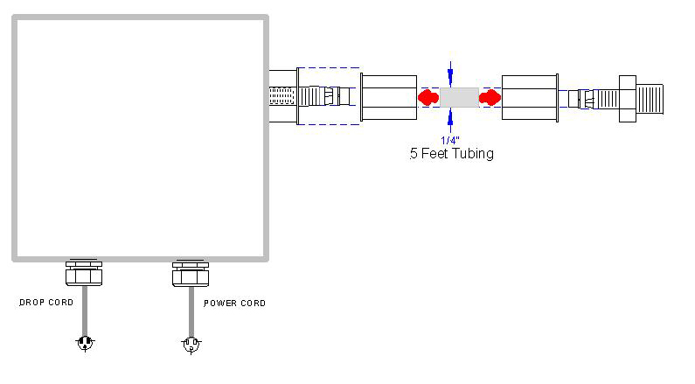
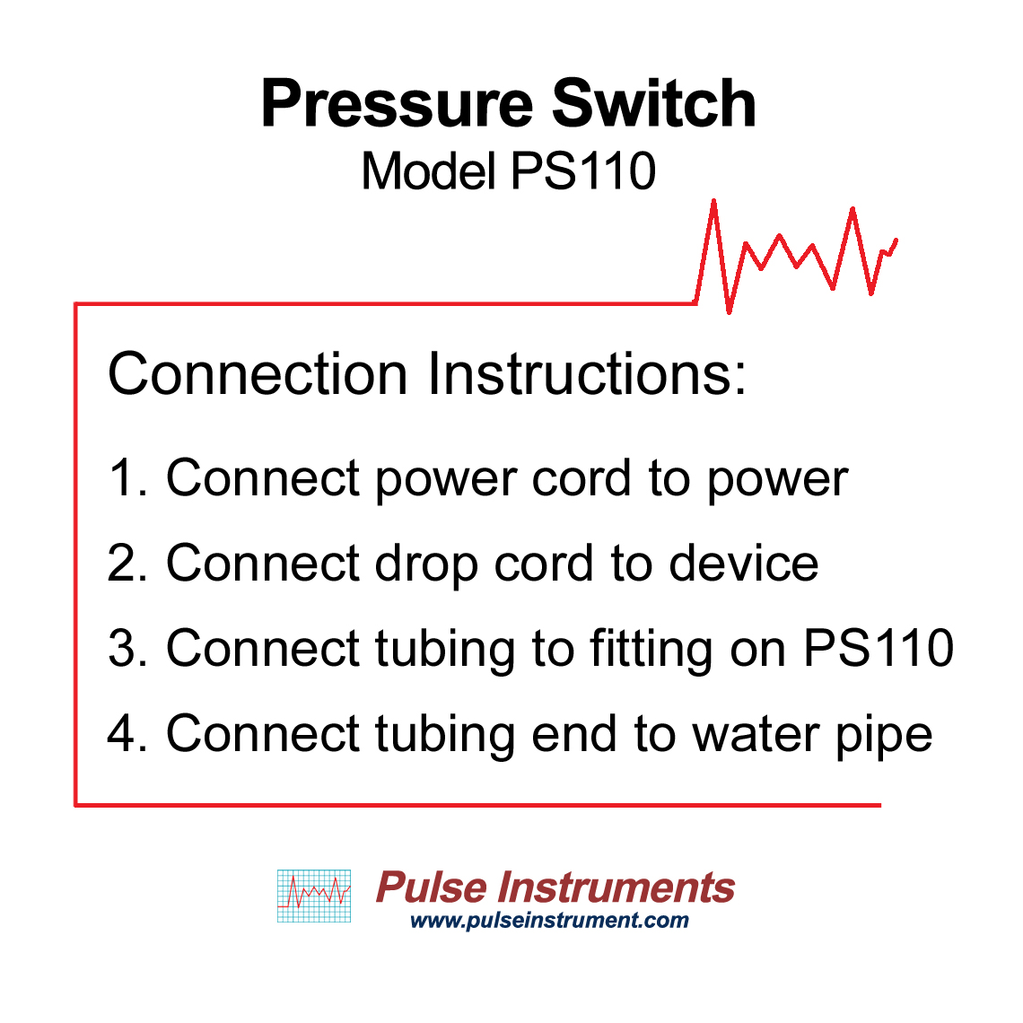
Water Pipe

Overview
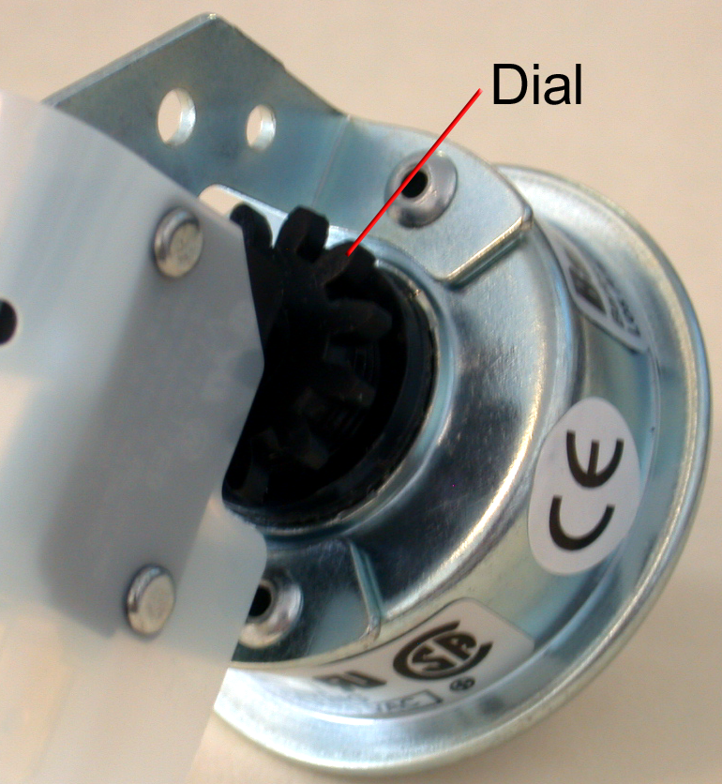
PS110, pressure switch comes with NEMA 4X enclosure with 110VAC power receptacle to plug in a device. The sensitivity of the pressure switch can be adjusted by turning the dial inside of the receptacle (see picture on the right). For high pressure, reduce sensitivity and loosen the dial. For low pressure, increase sensitivity and tighten the dial.

PS110 is easy to use and simple to install. Fittings, power cord, drop cord, along with a 5 feet tubing are provided in the package.

Specification
Pressure (MAX): 100 PSI
Adjustable Range: 1.5 – 15 PSI

Connection Instructions
1. Connect power cord to power
- Connect drop cord to device
- Connect tubing to fitting on PS110
- Connect tubing end to water pipe

